**Java Programming -II Div A**

Date:28th December 2019

Write a program in JAVA that will create two threads to display the following:

Example:

Thread1 handle one string “java” Thread2 handle another string “thread” and Output should be **“jathvaread”**

Write a java applet program tocreate **multithreads in java using Runnable interface** to do the following on the number taken from user and **set priorities to various threads**:

* 1. One thread display **each digit of the inputted number**
  2. Second thread display **reverse of the inputted number**
  3. Third thread display **sum of each digit of the inputted number**

Write a program that create 2 threads – each displaying a message (Pass the message as a parameter to the constructor). The threads should display the messages continuously till the user presses ctrl-c. Also display the thread information as it is running.

**Java Programming-II**

**Ass -2 Div A**

**Date :4th January 2020**

1. Develop a java program with user login form to authenticate the user through the database.
2. Write a java applet program to Check if a given String is Palindrome

**2.Create following form in java Applet**

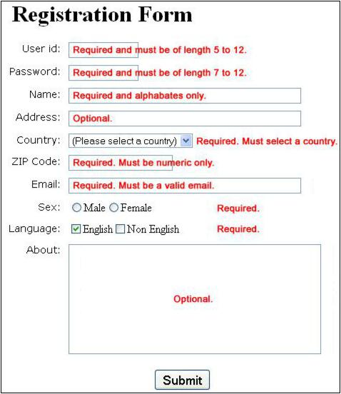

**Java Programming II DivA**

**Aim :Applet Ass 3**

**Date:18th January 2020**

Write a java applet program which has three radio buttons, on click of any radio button perform the following:

a) 1st radiobutton it will draw triangle,

b)2nd radiobutton it will draw rectangle

c)3rd radiobutton it will draw oval shape.

Write a **java applet** program which has 3 buttons, on click it generates different graphical shapes. Take a list box which displays different colours. On selection of the colour, the object should be filled by that colour.

Write a **java applet program** which perform STACK operation (push and pop ) by clicking on buttons(push and pop) displaying stack elements in LISTBOX .

Develop an applet that display the position of the mouse at the upper left corner of the applet when it is dragged or moved. Draw a rectangle filed with black at the current mouse position.

**Aim : JDBC and Applet**

1. Develop a java program with user login form to authenticate the user through the database.
2. Write a menu driven program (Command line interface) to perform the following operations on student table. 1. Insert 2. Modify 3. Delete 4. Search 5. View All 6. Exit

**Aim:JSP and Servlet, JDBC**

**Note:Session Management with JDBC**

Write the program for jsp and servlet to read n from user and return average of 1 to n numbers

Develop a simple JSP and servlet program for user registration page and then redirects the user on login page if registration is successful.

Develop a simple JSP and servlet program with user login form to authenticate the user through the database.

Consider the above program with state management. After login, Develop a JSP and servlet program to display the list of products in the drop down menu (products fetched from the table) and display the selected product information.

Developed a JSP and Servlet page to order above selected product, display detail for the same and insert data into relevant table.

Also display product wise all information in proper format.